**CUSTOMER INFORMATION SYSTEM**

**A PROJECT REPORT**

*Submitted in partial fulfilment for the award of the degree*

*of*

**Master of Technology**

***in***

**Information Technology**

*by*

**Suryakant Kashinath Dubalgunde**

**17MIN0395**

*Under the guidance of*

**Prof. Animesh Giri**

**Asst.Professor**



**School of Information Technology and Engineering**

December, 2020



**School of Information Technology and Engineering**

**BONAFIDE CERTIFICATE**

This is to certify that the project work entitled “**CUSTOMER INFORMATION SYSTEM”** by **SURYAKANT KASHINATH DUBALGUNDE(17MIN0395),** to Vellore Institute of Technology, Vellore, in partialfulfillment of the requirement for the award of the degree of **Master of Technology** in **Information Technology**, is a project bonafide work carried out by him under my supervision. The project fulfills the requirement as per the regulations of this Institute and in my opinion meets the necessary standards for submission. The contents of this report have not been submitted and will not be submitted either in part or in full, for the award of any other degree or diploma in this Institute or any other Institute or University.

**Prof. Animesh Giri**

**Internal Supervisor**

**Asst. Professor**

**VIT University**



**Internal Examiner** **External Examiner**

**ACKNOWLEDGEMENT**

It is great pleasure for me to acknowledge the assistance and support our professor, teachers and mentor for the successful completion of this project.

We take this opportunity to express our sincere gratitude to **Vellore Institute of** **Technology** for having provided us with a great opportunity to pursue ourMaster’s Degree in this institution.

We are highly indebted to our internal guide **Prof. Animesh Giri,** Asst.

Professor, Vellore Institute of Technology for his constant support and guidance.

He has been a great source of inspiration throughout the course of this project.

Finally, we gratefully acknowledge the support of our families during the completion of the project.

**Place**: Bangalore

Suryakant Kashinath Dubalgunde

**Date**: 20thDecember,2020

**Signature of the Candidate**

**ABSTRACT**

CIS(CUSTOMER INFORMATION SYSTEM) is a System suite that transforms Customer Raw Data into Practical Intelligence and Knowledge. CIS combines externally derived data and internally company sourced data to create data analysis and reporting and helps the company for rational decision making. This system helps to lists the strategies, effective decision-making processes, technologies, etc. and supports the organization to make business operational decisions. The main objective of developing this system is to structure and analyze the historical data within a company smart insights providing scope for rational decision making.CIS plays a pivotal role in the strategic planning of any organizations decision-making process which includes performance progress, quantitative analysis, reporting, data sharing and understanding customer insights. The CIS system involves the use of computing technologies to identify, analyze and forecast or predict customer views. It can help in efficient a quick decision-making process by analyzing the vitality of the various parameters based on the legacy customer data and help the enterprise come up with effective solutions based on the performance indicators.CIS also removes the requirement for manual data entry and interpretations and provides with quick reporting features and data visualizations.

**TABLE OF CONTENTS**

|  |  |  |  |  |
| --- | --- | --- | --- | --- |
| **CHAPTER** | **TITLE** | | **PAGE** |  |
| **NO.** | **NO.** |  |
|  |  |  |
|  | **ABSTRACT** | | 4 |  |
|  |  | |  |  |
|  | **LIST OF FIGURES** | | 7 |  |
|  |  | |  |  |
|  | **LIST OF TABLES** | | 8 |  |
|  |  | |  |  |
|  | **LIST OF ABBREVATIONS** | | 9 |  |
|  |  | |  |  |
| 1. | **INTRODUCTION** | | 10 |  |
|  |  |  |  |  |
|  | 1.1 | Project Overview | 10 |  |
|  |  |  |  |  |
|  | 1.2 | Scope | 11 |  |
|  |  |  |  |  |
|  | 1.3 | Objectives | 11 |  |
|  |  | |  |  |
| 2. | **LITERATURE SURVEY** | | 13 |  |
|  |  |  |  |  |
|  | 2.1 | Feasibility Study | 13 |  |
|  |  |  |  |  |
|  |  | 2.1.1 Technical Feasibility | 15 |  |
|  |  |  |  |  |
|  |  | 2.1.2 Economical Feasibility | 15 |  |
|  |  |  |  |  |
|  |  | 2.1.3 Operational Feasibility | 15 |  |
|  |  | |  |  |
| 3 | **DETAILED DESIGN OF THE PROJECT** | | 16 |  |
|  |  |  |  |  |
|  | 3.1 | System Architecture | 16 |  |
|  |  |  |  |  |
|  | 3.2 | Module Description | 17 |  |
|  |  |  |  |  |
|  | 3.3 | System Requirement Specification | 18 |  |
|  |  |  |  |  |
|  |  | 3.3.1. Hardware Specification | 18 |  |
|  |  |  |  |  |
|  |  | 3.3.2. Software Specification | 18 |  |
|  |  |  |  |  |
|  |  | 3.3.3 Functional & Non-Functional | 19 |  |
|  | Requirements | |  |
|  |  |  |
|  | 3.4 | Structural & Behavioral Diagrams | 23 |  |
|  |  |  |  |  |

|  |  |  |
| --- | --- | --- |
|  | 3.4.1 Data Flow Diagram | 23 |
|  |  |  |
|  | 3.4.2 Sequence Diagram | 23 |
|  |  |  |
|  | 3.4.3 System Diagram | 24 |
|  |  |  |
|  | 3.4.4 Use Case Diagram | 24 |
|  |  |  |
| 4 | **CONCLUSION** | 25 |
|  |  |  |
| 5 | **LIST OF REFERENCES** | 26 |
|  |  |  |

**LIST OF FIGURES**

|  |  |  |  |
| --- | --- | --- | --- |
| **Figure No** | **Title** | **Page No** |  |
|  |  |  |  |
| Fig. 3.1 | **Architecture diagram of Customer Information system.** | 16 |  |
|  |  |  |
|  |  |  |  |
| Fig. 3.4.1 | **Dataflow diagram** | 22 |  |
|  |  |  |  |
| Fig. 3.4.2. | **Sequence diagram** | 23 |  |
|  |  |  |  |
| Fig.3.4.3 | **System diagram** | 24 |  |
|  |  |  |
|  |  |  |  |
| Fig.3.4.4 | **Use case diagram** | 25 |  |
|  |  |  |  |

**LIST OF TABLES**

|  |  |  |
| --- | --- | --- |
| **Table No** | **Title** | **Page No** |
|  |  |  |
| NIL | NIL | NIL |
|  |  |  |

**LIST OF ABBREVIATIONS**

|  |  |  |
| --- | --- | --- |
| **ACRONYM** | **EXPANSION** |  |
|  |  |  |
| CIS | CIS(Customer Information System) is a System suite that transforms Customer Raw Data into Practical Intelligence and Knowledge. CIS combines externally derived data and internally company sourced data to create data analysis and reporting and helps the company for rational decision making. This system helps to lists the strategies, effective decision-making processes, technologies, etc. and supports the organization to make business operational decisions. |  |
|  |  |  |
|  |  |  |

**1 INTRODUCTION**

**1.1. Project Overview**

We are designing a system comprising of MSBI(Microsoft Business Intelligence)Suite. We are going to use three tools from MSBI Suite i.e. SSIS,SSAS,SSRS.The first tool i.e. SSIS is used to perform an ETL activity(Extracting the data from the various source systems,Transforming the data and Loading the data in datawarehouse).The second tool i.e. SSAS is used to perform an Analysis activity(Creating the Dimensions and Cubes of the data available in the datawarehouse for better Analysis.The third tool i.e. SSRS is used to perform an Reporting activity(Creating the Reports of the analysed data).

CIS is a System suite that transforms Customer Raw Data into Practical Intelligence and Knowledge.This system helps to lists the strategies, effective decision-making processes, technologies, etc. and supports the organization to make business operational decisions. The main objective of developing this system is to structure and analyze the historical data within a company smart insights providing scope for rational decision making.CIS plays a pivotal role in the strategic planning of any organizations decision-making process which includes performance progress, quantitative analysis, reporting, data sharing and understanding customer insights. The CIS system involves the use of computing technologies to identify, analyze and forecast or predict customer views. It can help in efficient a quick decision-making process by analyzing the vitality of the various parameters based on the legacy customer data and help the enterprise come up with effective solutions based on the performance indicators.CIS also removes the requirement for manual data entry and interpretations and provides with quick reporting features and data visualizations.

**1.2. Scope**

The traditional manual methods of managing,viewing,processing the customer informations are tedious as the someone have to be manually process the customer data. This is tedious, time consuming and prone to inaccuracies.Use of the face CIS system in lieu of the traditional methods will provide a fast and effective method of managing,viewing,processing customer data accurately. CIS combines externally derived data and internally company sourced data to create data analysis and reporting and helps the company for rational decision making. This system helps to lists the strategies, effective decision-making processes, technologies, etc. and supports the organization to make business operational decisions. The main objective of developing this system is to structure and analyze the historical data within a company smart insights providing scope for rational decision making.CIS plays a pivotal role in the strategic planning of any organizations decision-making process which includes performance progress, quantitative analysis, reporting, data sharing and understanding customer insights. The CIS system involves the use of computing technologies to identify, analyze and forecast or predict customer views. It can help in efficient a quick decision-making process by analyzing the vitality of the various parameters based on the legacy customer data and help the enterprise come up with effective solutions based on the performance indicators.CIS also removes the requirement for manual data entry and interpretations and provides with quick reporting features and data visualizations.

**1.3. Objectives**

The main objective of developing this system is to structure and analyze the historical data within a company smart insights providing scope for rational decision making.CIS plays a pivotal role in the strategic planning of any organizations decision-making process which includes performance progress, quantitative analysis, reporting, data sharing and understanding customer insights.

**2. LITERATURE SURVEY**

**2.1. FEASIBILITY STUDY**

Feasibility study is performed to check whether the proposed project is implementable and to know the benefits from the existing system. The most essential tasks performed by a Feasibility Study are the identification and description of systems, the evaluation of the systems and the selection of the best of the systems.

**2.1.1. Technical Feasibility**

Technical Feasibility study is performed to check whether the proposed system is technically feasible or not. Technical feasibility centers around the existing computer system (hardware, software, etc.) and to what extent it can support the proposed addition.

**2.1.2. Economic Feasibility**

Economic Feasibility Study is the most frequently used method for evaluating the effectiveness of a candidate system. More commonly known as cost/benefit analysis, the procedure is to determine the benefits and savings that are expected from a candidate system and compare them with cost. This analysis phase determines how much cost is needed to produce the proposed system. This system is economically feasible since it does not require any initial setup cost, as the organization has required machines and supporting programs for the application to execute itself. It does not need additional staffing requirements.

**2.1.3. Operational Feasibility**

Operational feasibility is a measure of how well a proposed system solves the problems, and takes advantage of the opportunities identified during scope definition and how it satisfies the requirements identified in the requirements analysis phase of system development. Operational Feasibility study is performed to check whether the system is operationally feasible or not.

**3. DETAILED DESGIN OF PROJECT**

**3.1. System Design and Architecture**

In this design, several related components in terms of functionality have been grouped to form sub- systems which then combine to make up the whole system. Breaking the system down to components and sub-systems informs the logical design of the CIS system.

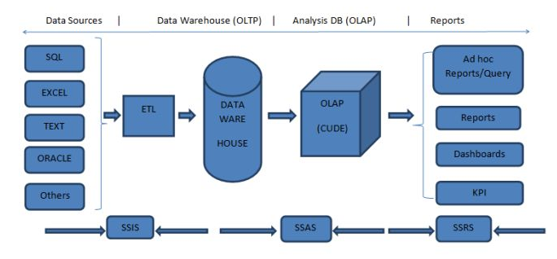 **Fig 3.1: Architecture diagram of CUSTOMER INFORMATION SYSTEM.**

Our system follows the three tier architecture. ETL,Analysis,Reporting tier

1)ETL-Should successfully extract,transform and load the data from the source to target.

2)Analysis-Should successfully able to create Dimensions and Cubes for better analysis purpose.

3)Reporting-Should successfully able to create the reports based on the analysed data.

**3.2. MODULE DESCRIPTION**

The following tools will be used in the implementation of the designed system.

**1)SSIS(SQL SERVER INTEGRATION SERVICE)-**

**SSIS is the ETL tool from Microsoft.Integration Services is a platform for building high-performance data integration and workflow solutions, including extraction, transformation, and loading (ETL) operations for data warehousing.We can process the data from various locations and various formats (source locations) and save the data into a centralized repository as a Data Warehouse/Data Mart (destination).It includes graphical tools and wizards for building and debugging packages.**SQL Server Integration Services is a platform for building enterprise-level data integration and data transformations solutions. Use Integration Services to solve complex business problems by copying or downloading files, loading data warehouses, cleansing and mining data, and managing SQL Server objects and data.Integration Services can extract and transform data from a wide variety of sources such as XML data files, flat files, and relational data sources, and then load the data into one or more destinations.

Integration Services includes a rich set of built-in tasks and transformations, graphical tools for building packages, and the Integration Services Catalog database, where you store, run, and manage packages.You can use the graphical Integration Services tools to create solutions without writing a single line of code. You can also program the extensive Integration Services object model to create packages programmatically and code custom tasks and other package objects.

**2)SSAS(SQL SERVER ANALYSIS SERVICE)-**

**This is the process of converting two dimensional (rows and columns/OLTP) data into a multi-dimensional data model (OLTP). This will help you to analyze the large volume of data.**SQL Server Analysis Services (SSAS) is the technology from the Microsoft Business Intelligence stack, to develop Online Analytical Processing (OLAP) solutions. In simple terms, you can use SSAS to create cubes using data from data marts / data warehouse for deeper and faster data analysis.Cubes are multi-dimensional data sources which have dimensions and facts (also known as measures) as its basic constituents. From a relational perspective dimensions can be thought of as master tables and facts can be thought of as measureable details. These details are generally stored in a pre-aggregated proprietary format and users can analyze huge amounts of data and slice this data by dimensions very easily. Multi-dimensional expression (MDX) is the query language used to query a cube, similar to the way T-SQL is used to query a table in SQL Server.Simple examples of dimensions can be product / geography / time / customer, and similar simple examples of facts can be orders / sales. A typical analysis could be to analyze sales in Asia-pacific geography during the past 5 years. You can think of this data as a pivot table where geography is the column-axis and years is the row axis, and sales can be seen as the values. Geography can also have its own hierarchy like Country->City->State. Time can also have its own hierarchy like Year->Semester->Quarter. Sales could then be analyzed using any of these hierarchies for effective data analysis.  
A typical higher level cube development process using SSAS involves the following steps:  
1) Reading data from a dimensional model  
2) Configuring a schema in BIDS (Business Intelligence Development Studio)  
3) Creating dimensions, measures and cubes from this schema  
4) Fine tuning the cube as per the requirements  
5) Deploying the cube

**Some of the advantages:**

**Multi-dimensional analysis**

**Key Performance Indicator (KPI)**

**Scorecard**

**Slice, dice, drill-down functionalities**

**Good performance**

**Security and so on.**

**3)SSRS(SQL SERVER REPORTING SERVICE)-**

**Microsoft SQL Server Reporting Services (SSRS) is an enterprise reporting platform supporting traditional and interactive reports delivered over the web or through custom applications. It supports various data sources like two dimensional and multi-dimensional.** SQL Server Reporting Services (SSRS) provides a set of on-premises tools and services that create, deploy, and manage mobile and paginated reports.The SSRS solution flexibly delivers the right information to the right users. Users can consume the reports via a web browser, on their mobile device, or via email.SQL Server Reporting Services offers an updated suite of products:

"Traditional" paginated reports brought up to date, so you can create modern-looking reports, with updated tools and new features for creating them.

New mobile reports with a responsive layout that adapts to different devices and the different ways you hold them.

A modern web portal you can view in any modern browser. In the new portal,you can organize and display mobile and paginated Reporting Services reports and KPIs. You can also store Excel workbooks on the portal.

**SQL Server Reporting Services (SSRS)** is a reporting software that allows you to produce formatted reports with tables in the form of data, graph, images, and charts. These reports are hosted on a server that can be executed any time using parameters defined by the users. It is part of Microsoft SQL Server Services suite.

**The following are some features of SSRS:**

**Retrieve data from a different source**

**Web-based access to reports**

**Support for Ad-hoc reporting**

**Report builder helps to customize the reports for end-user.**

**Easy subscriptions options**

**Export functionality with lots of formats.**

**Display reports in various ways like tabular, Chart, Gauge, and so on.**

**4)Visual Studio-**

**Visual Studio is the most powerful Universal Windows Platform development environment. It brings unparalleled productivity improvements, a streamlined acquisition experience and enhanced debugging tools for Universal Windows Platform developers. Microsoft Visual Studio is an [integrated development environment](https://en.wikipedia.org/wiki/Integrated_development_environment) (IDE) from [Microsoft](https://en.wikipedia.org/wiki/Microsoft). It is used to develop [computer programs](https://en.wikipedia.org/wiki/Computer_program), as well as [websites](https://en.wikipedia.org/wiki/Web_site), [web apps](https://en.wikipedia.org/wiki/Web_app), [web services](https://en.wikipedia.org/wiki/Web_service) and [mobile apps](https://en.wikipedia.org/wiki/Mobile_app). Visual Studio uses Microsoft software development platforms such as [Windows API](https://en.wikipedia.org/wiki/Windows_API), [Windows Forms](https://en.wikipedia.org/wiki/Windows_Forms), [Windows Presentation Foundation](https://en.wikipedia.org/wiki/Windows_Presentation_Foundation), [Windows Store](https://en.wikipedia.org/wiki/Windows_Store) and [Microsoft Silverlight](https://en.wikipedia.org/wiki/Microsoft_Silverlight). It can produce both [native code](https://en.wikipedia.org/wiki/Machine_code) and [managed code](https://en.wikipedia.org/wiki/Managed_code).Visual Studio includes a [code editor](https://en.wikipedia.org/wiki/Code_editor) supporting [IntelliSense](https://en.wikipedia.org/wiki/IntelliSense) (the [code completion](https://en.wikipedia.org/wiki/Code_completion) component) as well as [code refactoring](https://en.wikipedia.org/wiki/Code_refactoring). The integrated debugger works both as a source-level debugger and a machine-level debugger. Other built-in tools include a [code profiler](https://en.wikipedia.org/wiki/Profiling_(computer_programming)), designer for building [GUI](https://en.wikipedia.org/wiki/GUI) applications, [web designer](https://en.wikipedia.org/wiki/Web_designer), [class](https://en.wikipedia.org/wiki/Class_(computing)) designer, and [database schema](https://en.wikipedia.org/wiki/Database_schema) designer. It accepts plug-ins that expand the functionality at almost every level—including adding support for [source control](https://en.wikipedia.org/wiki/Source_control) systems (like [Subversion](https://en.wikipedia.org/wiki/Subversion_(software)) and [Git](https://en.wikipedia.org/wiki/Git)) and adding new toolsets like editors and visual designers for [domain-specific languages](https://en.wikipedia.org/wiki/Domain-specific_language) or toolsets for other aspects of the [software development lifecycle](https://en.wikipedia.org/wiki/Software_development_lifecycle) (like the [Azure DevOps](https://en.wikipedia.org/wiki/Azure_DevOps_Server) client: Team Explorer).**

**5)SQL SERVER MANAGEMENT STUDIO-**

**SQL Server Management Studio (SSMS) is an integrated environment for managing any SQL infrastructure. Use SSMS to access, configure, manage, administer, and develop all components of SQL Server, Azure SQL Database, and Azure Synapse Analytics. SSMS provides a single comprehensive utility that combines a broad group of graphical tools with a number of rich script editors to provide access to SQL Server for developers and database administrators of all skill levels.SQL Server Management Studio (SSMS) is a software application first launched with [Microsoft](https://en.wikipedia.org/wiki/Microsoft) [SQL Server 2005](https://en.wikipedia.org/wiki/Microsoft_SQL_Server) that is used for configuring, managing, and administering all components within [Microsoft SQL Server](https://en.wikipedia.org/wiki/Microsoft_SQL_Server). It's the successor to the Enterprise Manager in SQL 2000 or before. The tool includes both script editors and graphical tools which work with objects and features of the server.A central feature of SSMS is the Object Explorer, which allows the user to browse, select, and act upon any of the objects within the server. It also shipped a separate Express edition that could be freely downloaded, however recent versions of SSMS are fully capable of connecting to and manage any SQL Server Express instance. Microsoft also incorporated backwards compatibility for older versions of SQL Server thus allowing a newer version of SSMS to connect to older versions of SQL Server instances. It also comes with Microsoft SQL Server Express 2012, or users can download it separately.**

**3.3. SYSTEM REQUIREMENT SPECIFICATION**

**3.3.1. Hardware Specification**

Hardware Requirements:

The system should run on Microsoft windows based system.

Processor : Intel Core i3 or higher

Speed : 1.70 GHz or higher

RAM : 4 GB or higher

Hard Disk : 100 GB or higher

**3.3.2. Software Specification**

**Software Requirements:**

**Operating System : Windows 8.1 or higher**

**Front-End Tool : Visual Studio 2017**

**Back-End Tool : MS SQL Server Developer Edition 2017**

**Front-End Technologies : SSIS,SSAS,SSRS,SQL**

**Back-End Technologies : SQL**

**3.3.3. Functional Requirements**

Below section contains a detailed description of Functional requirements.

These are the statements of services that the system should provide, how the system should react for particular inputs and behave in particular situations.

* Should extract the Same Pre-defined Structured Raw Customer data from the CSV file.
* If CSV file is not found in the Pre-defined location,then should trigger the mail automatically.
* Should transform the Raw Customer Data into Customer Information.
* If CSV file has some corrupted data,then the corrupted data should not flow in final target table.
* If interface fails to execute then it should log the exception in Logging table and should notify to client.
* Should successfully load the Customer Information into the Customer Datawarehouse.
* Should analyze the Customer Information from the Customer Datawarehouse with the help of cubes.
* Should able to generate the reports for data visualization.

**3.3.4.** **Non-Functional requirements**

Below section contains a detailed description of Non-Functional requirements.

Non-Functional requirements define the needs in terms of performance, logical database requirements, design constraints, standards compliance, reliability, availability, security, maintainability, and portability.

* PERFORMANCE:-System should provide the response within an acceptable time.
* RELIABILITY:- The outcome from the system should be reliable.
* AVAILABILITY:- The system shall be available for all the time.
* SECURITY:-Various location should be accessible by authorized users.
* MAINTAINABILITY:-System should be easily maintainable.
* PORTABILITY:-The System should be easily portable from one system to another system.

**3.4. Structural & Behavioral Diagrams**

**3.4.1. Dataflow Diagram**

A data flow diagram is the graphical representation of the flow of data through an information system. DFD is very useful in understanding a system and can be efficiently used during analysis.

A DFD shows the flow of data through a system. It views a system as a function that transforms the inputs into desired outputs. Any complex systems will not perform this transformation in a single step and a data will typically undergo a series of transformations before it becomes the output.

With a data flow diagram, users are able to visualize how the system will operate that the system will accomplish and how the system will be implemented, old system data flow diagrams can be drawn up and compared with a new systems data flow diagram to draw comparisons to implement a more efficient system.

**A data-flow diagram is a way of representing a flow of data through a [process](https://en.wikipedia.org/wiki/Process) or a system (usually an [information system](https://en.wikipedia.org/wiki/Information_system)). The DFD also provides information about the outputs and inputs of each entity and the process itself.**

**A data-flow diagram has no control flow, there are no decision rules and no loops. Specific operations based on the data can be represented by a [flowchart](https://en.wikipedia.org/wiki/Flowchart).There are several notations for displaying data-flow diagrams. The notation presented above was described in 1979 by [Tom DeMarco](https://en.wikipedia.org/wiki/Tom_DeMarco) as part of Structured Analysis.For each data flow, at least one of the endpoints (source and / or destination) must exist in a process. The refined representation of a process can be done in another data-flow diagram, which subdivides this process into sub-processes.**

**The data-flow diagram is part of the structured-analysis modeling tools. When using [UML](https://en.wikipedia.org/wiki/Unified_Modeling_Language), the [activity diagram](https://en.wikipedia.org/wiki/Activity_diagram) typically takes over the role of the data-flow diagram. A special form of data-flow plan is a site-oriented data-flow plan.**

**Data-flow diagrams can be regarded as inverted [Petri nets](https://en.wikipedia.org/wiki/Petri_nets), because places in such networks correspond to the semantics of data memories. Analogously, the semantics of transitions from Petri nets and data flows and functions from data-flow diagrams should be considered equivalent.**



**Fig. 3.4.1 Dataflow**

**3.4.2. Sequence Diagram**

**A sequence diagram shows object interactions arranged in time sequence. It depicts the objects involved in the scenario and the sequence of messages exchanged between the objects needed to carry out the functionality of the scenario. Sequence diagrams are typically associated with use case realizations in the [Logical View](https://en.wikipedia.org/wiki/4%2B1_architectural_view_model) of the system under development. Sequence diagrams are sometimes called event diagrams or event scenarios.**

**A sequence diagram shows, as parallel vertical lines (*lifelines*), different processes or objects that live simultaneously, and, as horizontal arrows, the messages exchanged between them, in the order in which they occur. This allows the specification of simple runtime scenarios in a graphical manner.**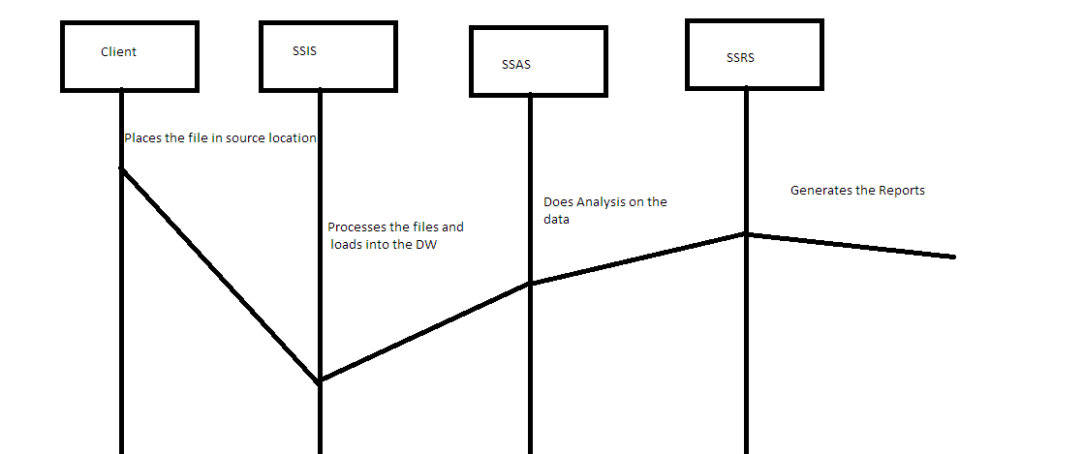

**Fig 3.4.2 Sequence diagram**

**3.4.3. System Diagram**

**A system context diagram (SCD) in [engineering](https://en.wikipedia.org/wiki/Engineering) is a [diagram](https://en.wikipedia.org/wiki/Diagram) that defines the boundary between the [system](https://en.wikipedia.org/wiki/System), or part of a system, and its environment, showing the entities that interact with it. This diagram is a high level view of a [system](https://en.wikipedia.org/wiki/System). It is similar to a [block diagram](https://en.wikipedia.org/wiki/Block_diagram).**

.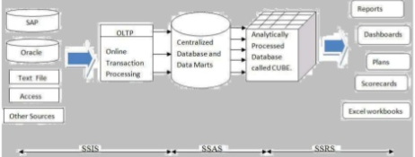

**Fig.3.4.3 System Diagram**

**3.4.4. Use case Diagram**

**A use case diagram at its simplest is a representation of a user's interaction with the system that shows the relationship between the user and the different [use cases](https://en.wikipedia.org/wiki/Use_case) in which the user is involved. A use case diagram can identify the different types of users of a system and the different use cases and will often be accompanied by other types of diagrams as well. The use cases are represented by either circles or ellipses.**

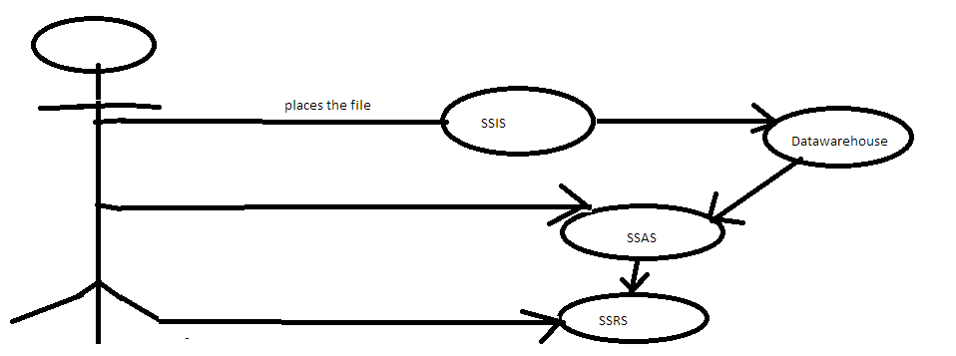

**Fig.3.4.4 Use case diagram**

**CONCLUSION**

This project serves to automate the prevalent traditional tedious and time-wasting methods of providing the Customer information in minimum time. The use of this system will help to reduce the manual work lists the strategies, effective decision-making processes, technologies, etc. and supports the organization to make business operational decisions. The main objective of developing this system is to structure and analyze the historical data within a company smart insights providing scope for rational decision making.CIS plays a pivotal role in the strategic planning of any organizations decision-making process which includes performance progress, quantitative analysis, reporting, data sharing and understanding customer insights. The CIS system involves the use of computing technologies to identify, analyze and forecast or predict customer views. It can help in efficient a quick decision-making process by analyzing the vitality of the various parameters based on the legacy customer data and help the enterprise come up with effective solutions based on the performance indicators.CIS also removes the requirement for manual data entry and interpretations and provides with quick reporting features and data visualizations.Currently we have completed the Analysis, Planning and the design phase. In the coming future, we commit to develop a working model as part of the Implementation and coding phase.

**5. LIST OF REFERENCES**

**1)Wikipedia-https://en.wikipedia.org/wiki/**

**2)C-Sharp Cornor-https://www.c-sharpcorner.com**